**RYTHMIC TUNES – FRONT END DOCUMENTATON WITH REACT JS**

**1. Introduction**

**Project Title:**

**Team Members:**

* Abdul Ghafoor– Team Leader
* Ajai– Member
* Magesh waran – Member
* Kishore Kumar – Member

**2.Overview:**

* Rhythmic Tunes is an application for discovering, playing, and managing music. The front-end is built using modern web technologies and frameworks to create a smooth, interactive, and visually appealing user experience.
* Rhythmic tunes are often associated with a strong, consistent beat that drives the music forward. They can be found in many genres, including pop, hip-hop, dance, funk, jazz, and world music. Rhythmic tunes typically focus on a compelling groove that encourages movement or dancing.

**3.Features:**

**1. Steady Tempo:**

* Rhythmic tunes often have a clear and consistent tempo, which sets the pace for the song. This steady rhythm makes it easier for listeners to tap their feet, clap along, or dance.

**2. Strong Beat:**

* The beat, especially the downbeat (the first beat of the measure), is very prominent in rhythmic tunes. This strong beat is what helps create a sense of movement and energy in the music.

**3. Syncopation:**

* Rhythmic tunes frequently use syncopation, where the emphasis falls on weak or off-beats, creating a sense of surprise and groove. This technique is common in genres like jazz, funk, and hip-hop.

**4. Groove:**

* Groove refers to the "feel" of the rhythm, where the instruments lock in and create a compelling, infectious rhythm. It's often the most important feature in dance music, where the focus is on making people move.

**5. Repetition:**

* Rhythmic tunes often feature repeating patterns, whether in the percussion, basslines, or melodies. Repetition helps anchor the listener, making it easy to groove along and remember the tune.

**6. Percussion Elements:**

* Percussion instruments like drums, congas, bongos, and even electronic beats are central to rhythmic tunes. These elements help establish the rhythmic backbone of the song and enhance the sense of movement.

**7. Polyrhythms:**

* Some rhythmic tunes use multiple contrasting rhythms played simultaneously, known as polyrhythms. This is common in genres like Afrobeat, Latin music, and progressive rock, where

**4.Setup Instructions**

**Prerequisites:**

* Node.js (v16 or later)
* npm or yarn
* Git
* Code Editor (VS Code recommended)
* **Installation Guide:**
* # Clone the repository
* git clone <https://github.com/your-username/rythmic>tunes.git
* cd rythmic tunes
* # Install dependencies
* npm install # or yarn install
* # Set up environment variables
* cp .env.example .env
* Configure .env file:
* REACT_APP_API_KEY=your_api_key_here
* REACT_APP_API_BASE_URL=https://api.coingecko.com/api/v3
* Run the development server:
* npm start # or yarn start

**5. Folder Structure**

* rythmic tunes/
* ├── public/ # Static assets
* ├── src/
* │ ├── components/ # Reusable UI components
* │ ├── pages/ # Page components
* │ ├── redux/ # Redux slices and store
* │ ├── utils/ # Helper functions and API calls
* │ ├── styles/ # Global styles and themes
* │ ├── App.js # Main app component
* │ ├── index.js # App entry point
* ├── .env # Environment variables
* ├── package.json # Project dependencies
* └── README.md # Project documentation

**6. Running the Application**

* npm start # or yarn start

**7. Component Documentation**

* **Key Components:**
* **App.js :  The App.use() function in Express.js adds middleware to the application's request-processing pipeline. It applies the specified middleware to all incoming requests**
* **Main.js :** **Main.js: this is the entry point to your application. Currently, this file initializes your Vue application and signifies which HTML element in the index.html file your app should be attached to.**

**8. User Authentication**

* Users can log in using email/password or social login (e.g., Google, Facebook).
* Once authenticated, users can manage their playlists and favorite songs

**9. User Interface**

* **Key Components:**
* **Project Execution:** he
* After completing the code, run the react application by using the command “npm start” or “npm run dev” if you are using vite.js
* And the Open new Terminal type this command “json-server --watch ./db/db.json” to start the json server too.
* After that launch the Rythimic Tunes.
* Here are some of the screenshots of the application.

## Hero components

* 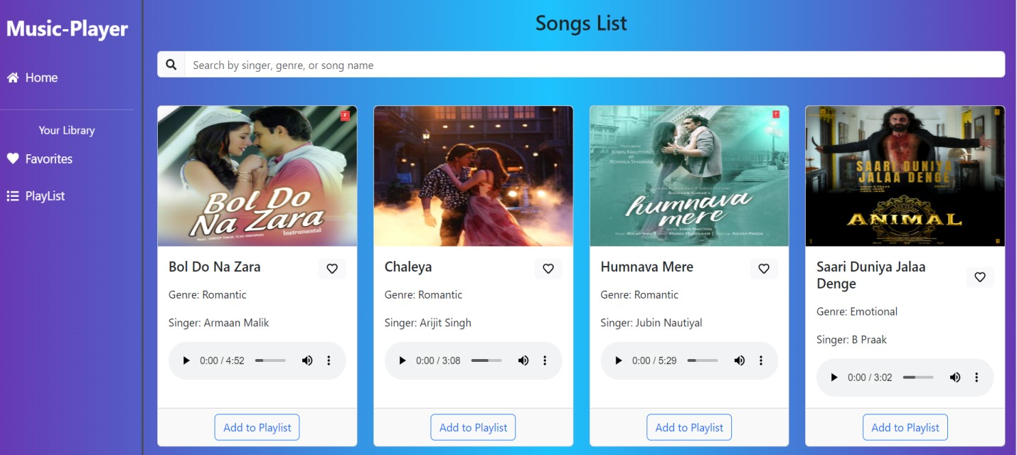
* 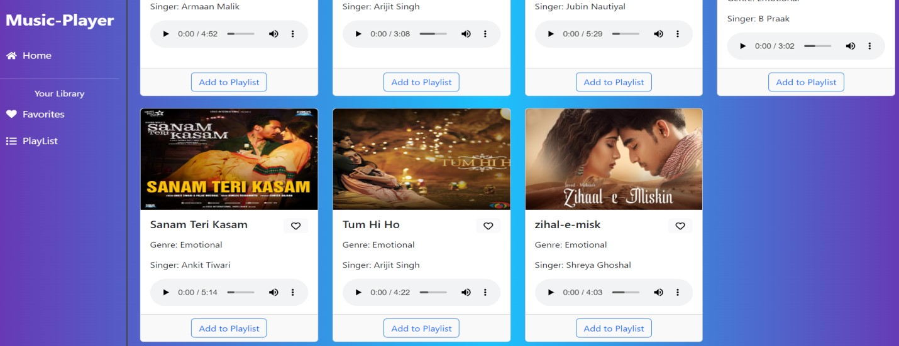

## Playlist

* 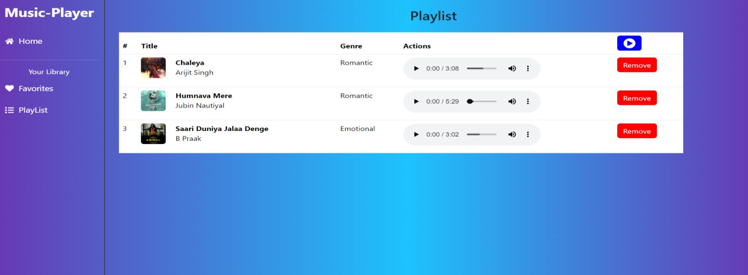

## Favorites

**10. Styling**

**CSS Frameworks/Libraries:**

* Tailwind CSS for modern, responsive design.
* Styled-Components for dynamic styling.

**Theming:**

* Dark mode toggle with persisted user settings.
* Customizable themes with predefined color palettes.

**11. Testing**

**Testing Strategy:**

* **Jest & React Testing Library** for unit and integration tests.
* **Cypress** for end-to-end (E2E) testing.

**Code Coverage:**

npm test # or yarn test

**12. Known Issues**

* Some API endpoints have rate limits.
* Improve responsiveness for smaller screens.

Optimize search performance for large datasets

**13. Future Enhancements**

* Implement user authentication (OAuth/Firebase/Auth0).
* Add advanced analytics and AI-driven market predictions.
* Expand fiat currency support and multi-language options.

Improve accessibility with screen reader support